USER GUIDE
PETBot Company

- Overview
- This website contains Home, Product chart, Contact Us, Register, Login, Site map, Category (Food and beverage, Pharmaceutical, Healthcare, Industry, Honey), Quick Order, Our catalogue, Feedback, Our Gallery.
- Before you begin, please make sure that you have a working internet connection.
- Click on Home.html locate inside the folder Source Code file to get start
- Instruction
This section contains some instruction on how to navigate the website:
1. Company name
- Company name lives on the top center of the page. This is PETBot Company.
2. Navigation bar
- Navigation bar contain information about all the main pages of the website, locate below the company name, right column and left column.
- To go to a particular page, click on the page name in the navigation bar:
- To go to home page, please click on HOME
- To go to Product chart, please click on PRODUCT
- To go to Contact us page, please click on CONTACT US
- To go to Register page, please click on REGISTER
- To go to login page, please click on LOGIN
- To go to Site Map, please click on SITE MAP
- To go to Order, please click on Quick Order
- To go to see our Catalogue, please click on Our Catalogue
- To go to send feedback, please click on Feedback
- To go to see our gallery, please click on Gallery
- To go to Food bottle or Food jars, please hover on Food and Beverage, there will be a drop-down options for you to choose Food bottle or Food jars.
- To go to Pharmaceutical, please click on Pharmaceutical
- To go to Healthcare bottle or Healthcare jars, please hover on Healthcare, there will be a drop-down options for you to choose Healthcare bottle or Healthcare jars.
- To go to Industry, please click on Industry
- To go to Honey, please click on Honey
III. Information about the Web pages
This section contains information about each page in the website

- Homepage:
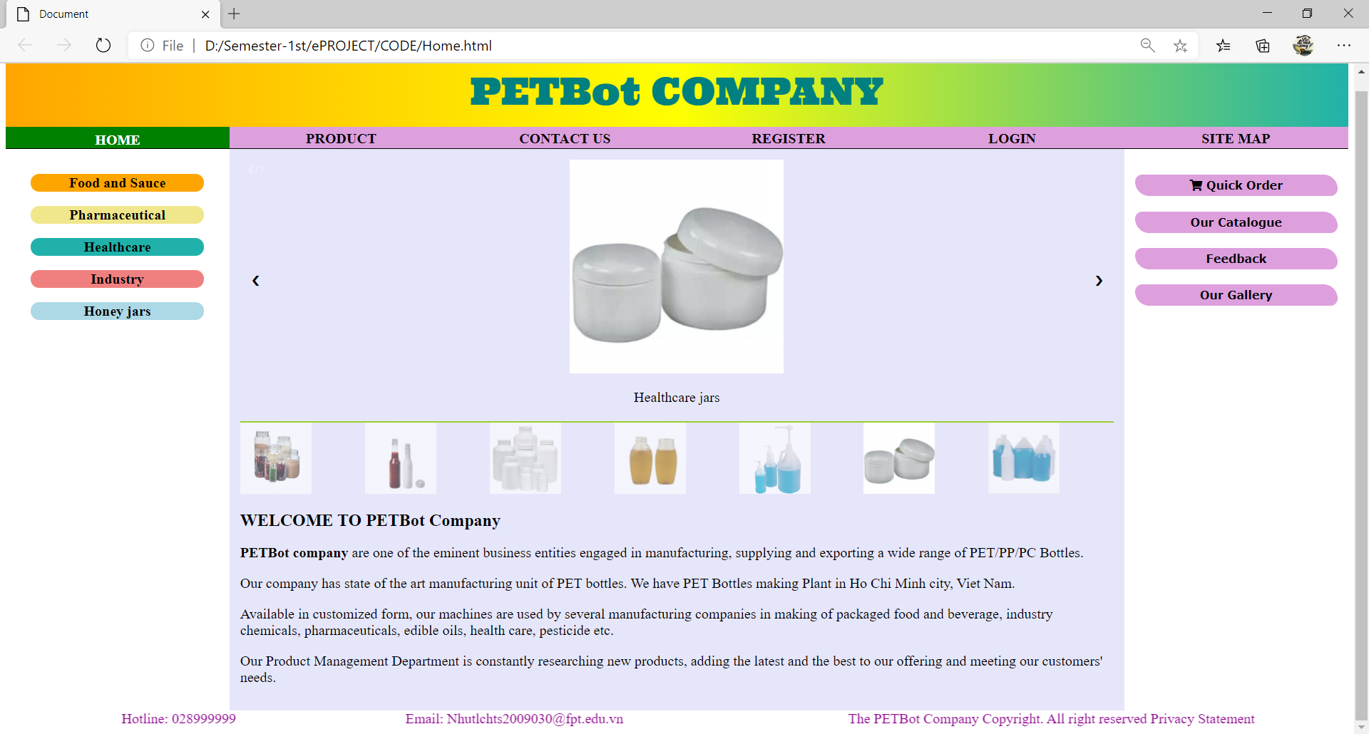
Description : Home page: Company introduction and some product images.
From : Home navigation bar
To : Product, Contact Us, Register, Login, Site Map, Category, Our Gallery, Our Catalogue, Quick Order, Feedback.

- Product:
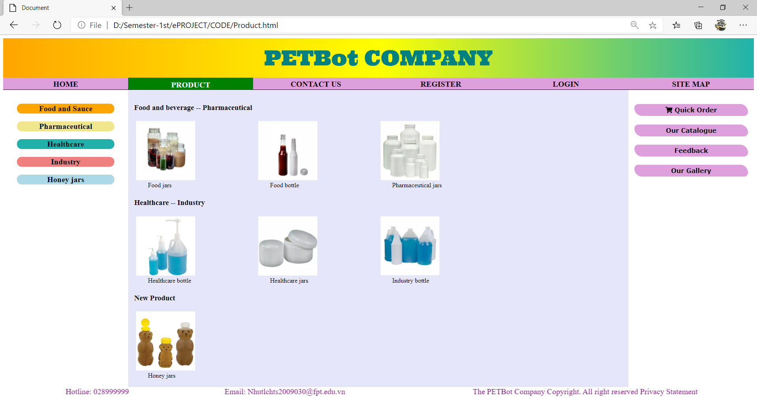

Description : Product: Product chart. You can go to the wanted product by click the picture of this product.
From : Home / Our Product navigation bar
To : Home, Contact Us, Register, Login, Site Map, Category, Our Gallery, Our Catalogue, Quick Order, Feedback.

- SITE MAP:
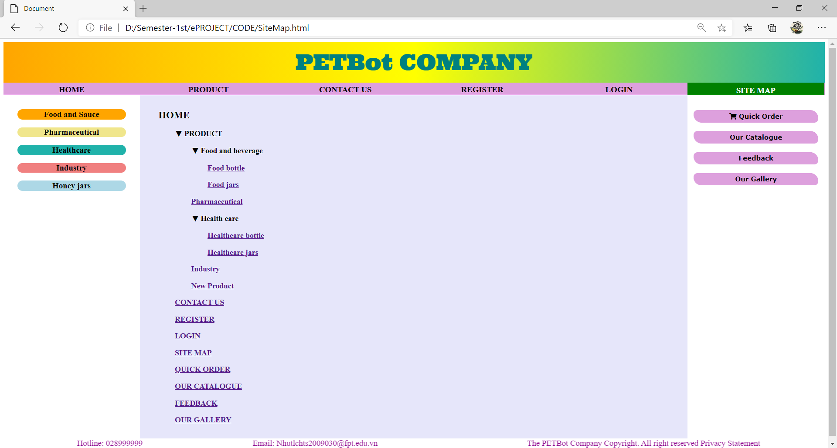
Description : Site Map you can go directly the wanted page by click the name page in the site map
From : Home / Site Map navigation bar
To : Home, Contact Us, Register, Login, Product, Category, Our Gallery, Our Catalogue, Quick Order, Feedback.

- Gallery:
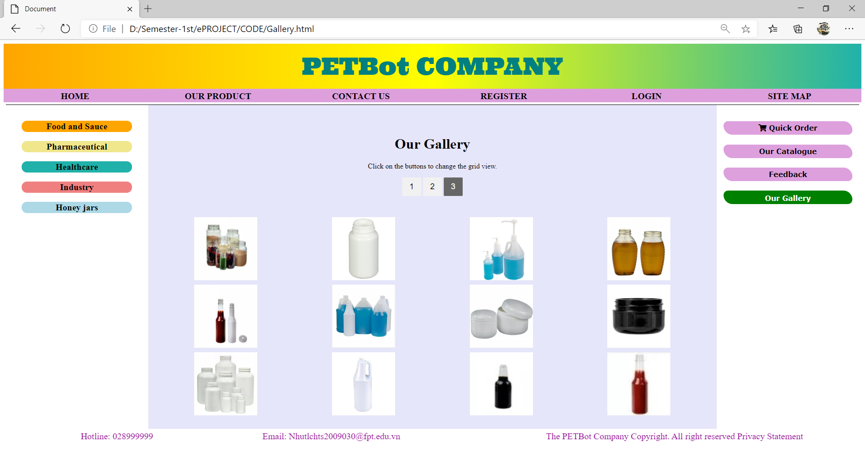
Description : Gallery: hover product picture, you can see the tittle of category of product that can help you find product easily by category.
From : Home / Gallery navigation bar
To : Home, Contact Us, Register, Login, Our Product, Category, Site Map, Our Catalogue, Quick Order, Feedback.

- CATEGORY:
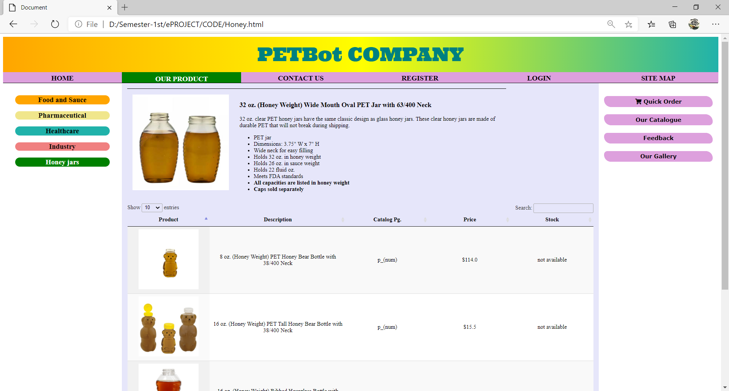
Description : Category left column: Pharmaceutical/Food bottle/Food jars/Industry/Healthcare bottle/Healthcare jars
From : Home / Our Product navigation bar / Category(…)
To : Home, Contact Us, Register, Login, Site Map, Category, Our Gallery, Our Catalogue, Quick Order, Feedback.

- CONTACT US
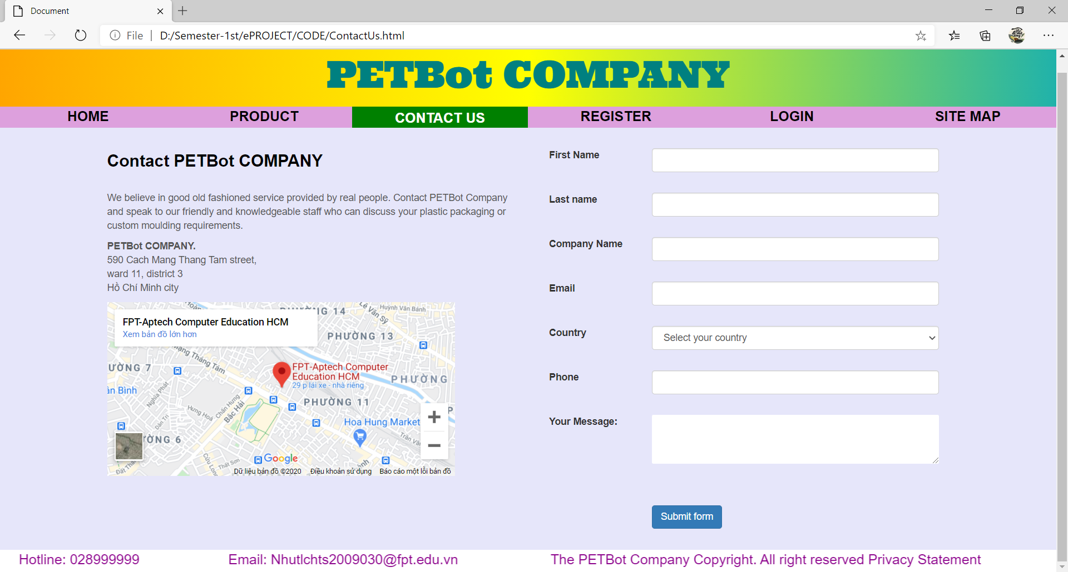
Description : Contact Us: Contact form and Geolocation. You should enter you information (such as first name, last name, email, country, phone and your message)
From : Home / Contact Us navigation bar
To : Home, Product, Register, Login, Site Map

- REGISTER
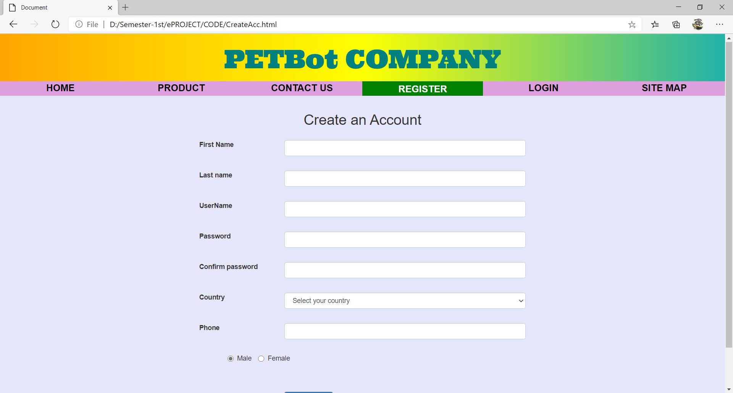
Description : Register : Register form to create new account
From : Home / Register navigation bar
To : Home, Product, Contact Us, Login, Register, Site Map,

- LOGIN:
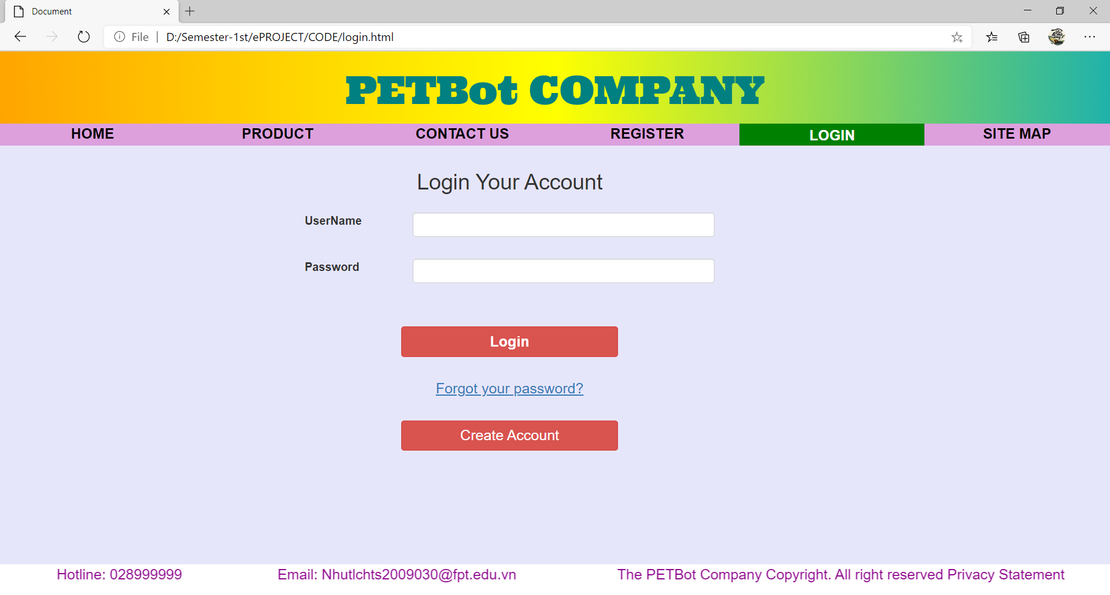
Description : Login : Login your account form
From : Home / Login navigation bar
To : Home, Our Product, Contact Us, Login, Register, Site Map,

- Quick Order:
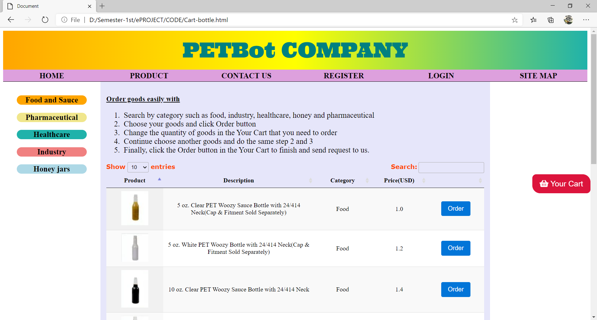

Description : Quick Order : Cart and list of all product with description, category, price.
From : Home / Quick Order navigation bar
To : Home, Our Product, Contact Us, Login, Register, Site Map, Category,

- Our Catalogue:
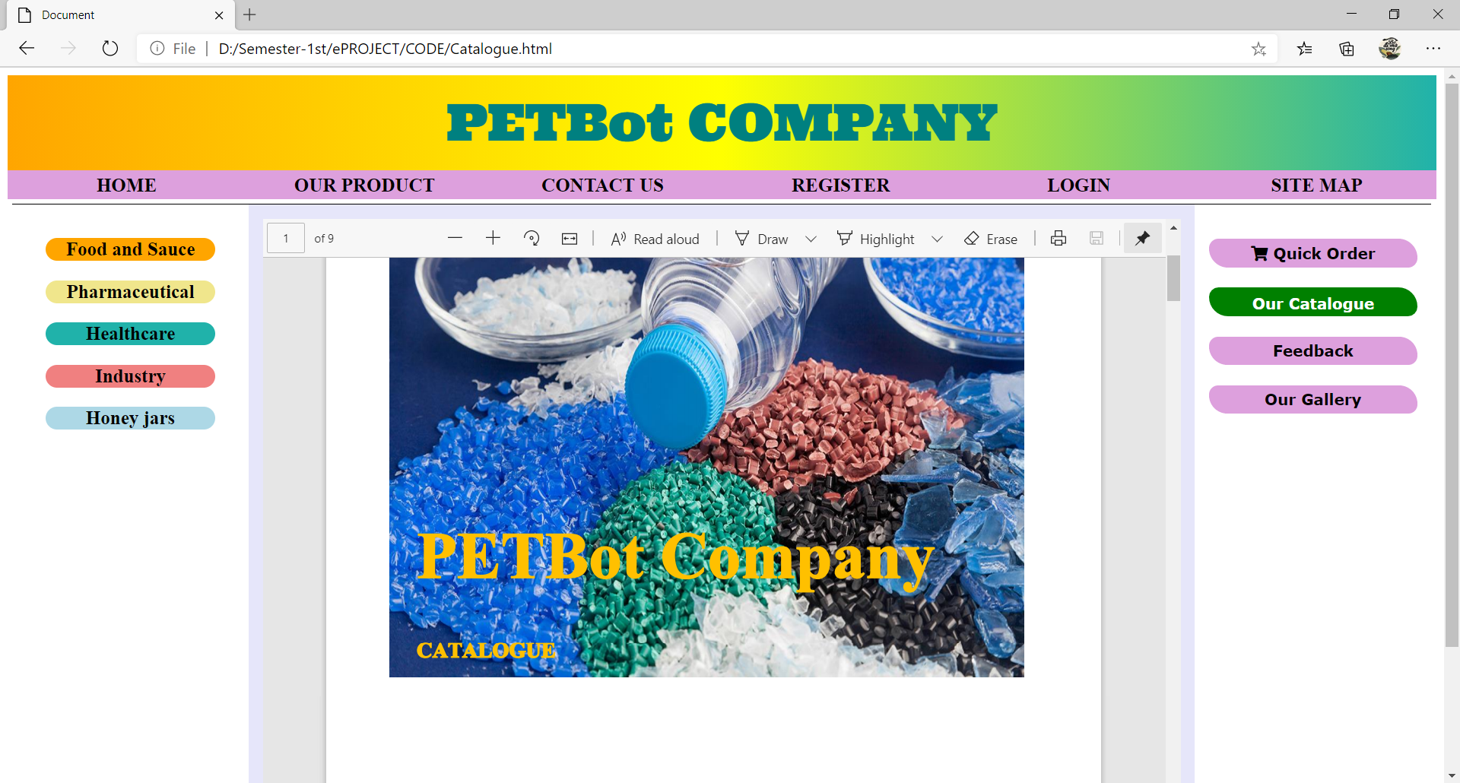

Description : Our Catalogue : Catalogue.pdf
From : Home / Our catalogue navigation bar
To : Home, Our Product, Contact Us, Login, Register, Site Map, Category,
Quick Order, Feedback, Our Gallery.

